# Website Links

Turing Link - <http://turing.algomau.ca/~swilding/>

notTuring Link - <https://notturing.ddns.net/tyler/IT_FProj/index.html>

Source Code Link - <https://github.com/xTVaser/Schoolwork-Fall-2016/tree/master/Internet%20Tools/Final%20Project/Source>

**Please note that due to the same-origin policy security standards used on ALL BROWSERS, the Visualization on the Media page will not work unless viewing it on the online uploads because the audio file will not be allowed to play.**

**For more information read about it here** [**https://developer.mozilla.org/en-US/docs/Web/Security/Same-origin_policy**](https://developer.mozilla.org/en-US/docs/Web/Security/Same-origin_policy)

# 

# 

# Sitemap

Internet Tools Sitemap.png

# 

# 

# Wireframe

## Home

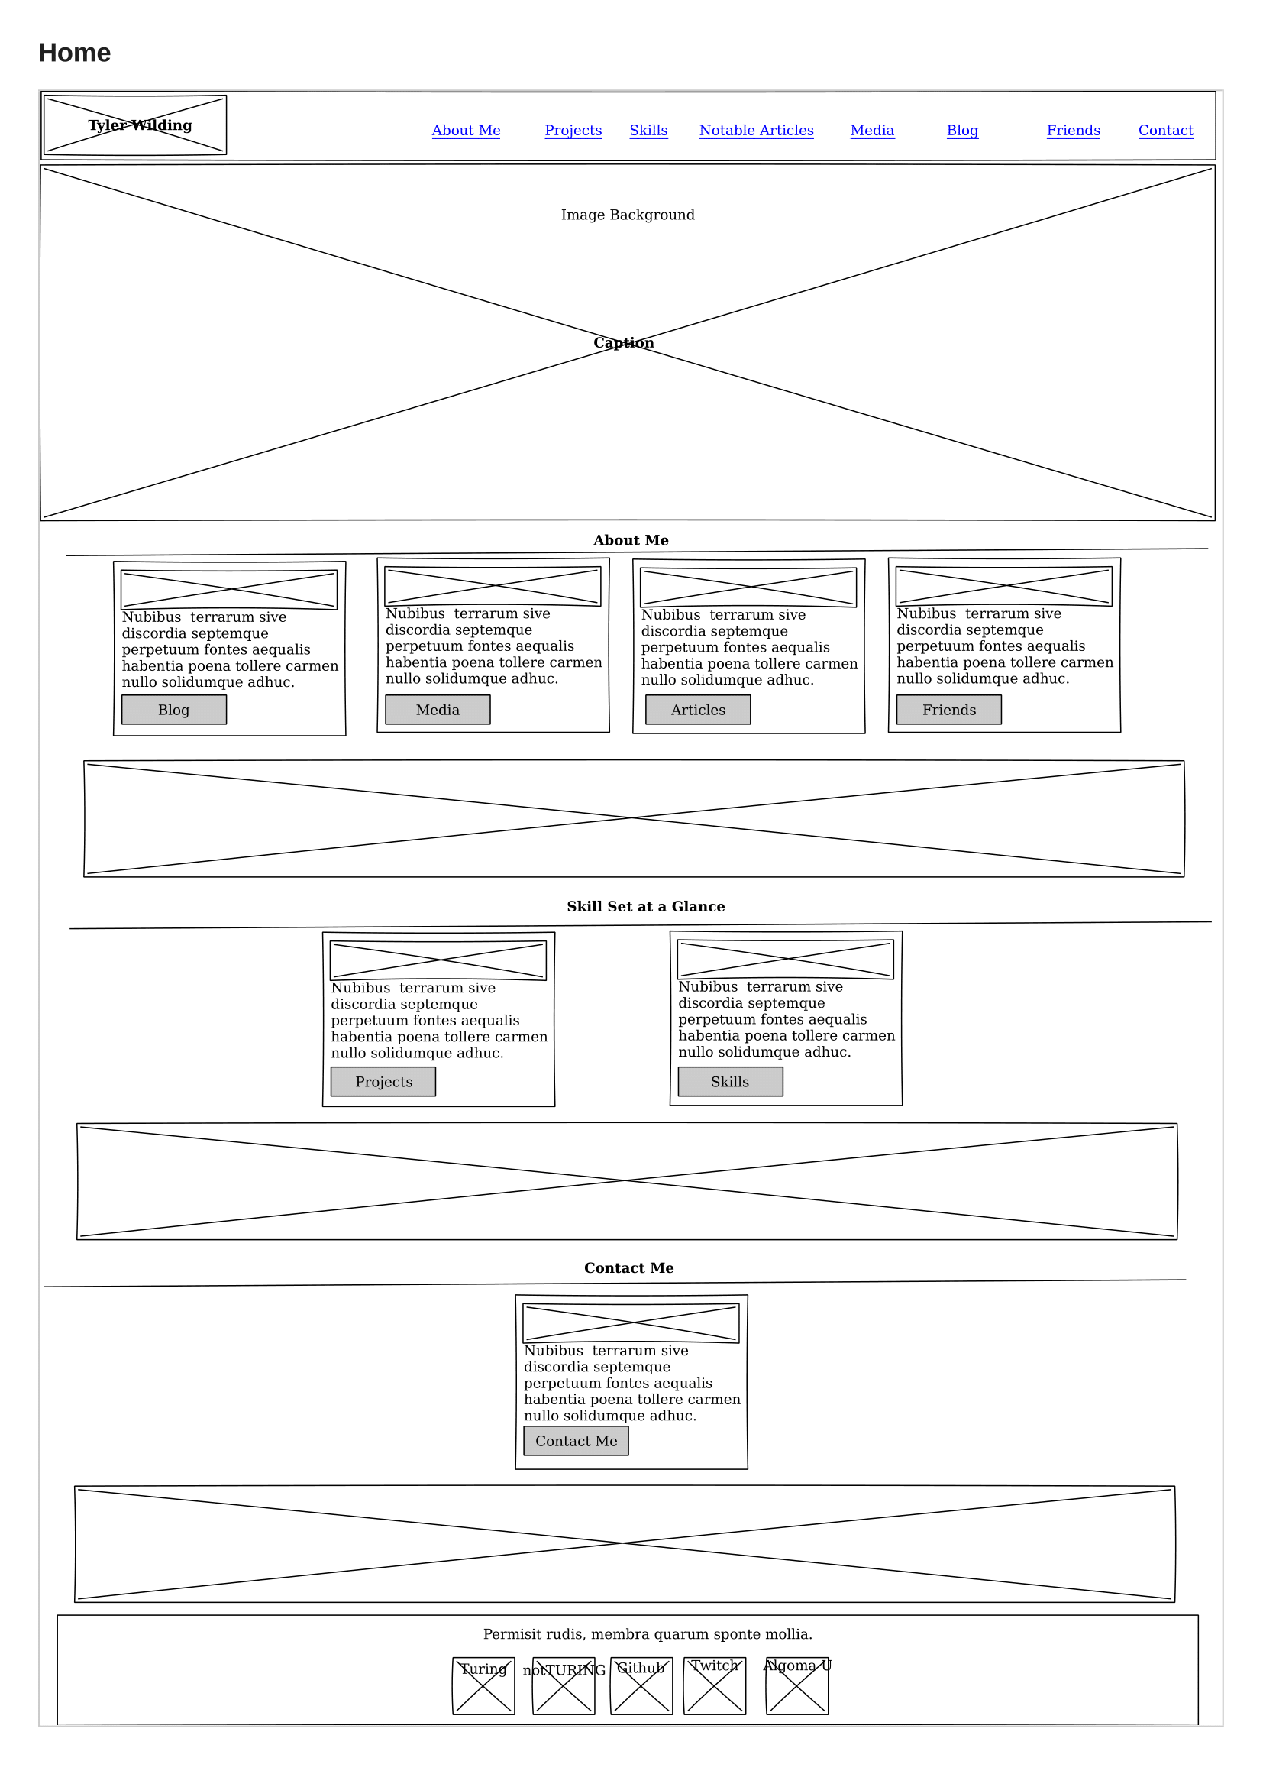

## About

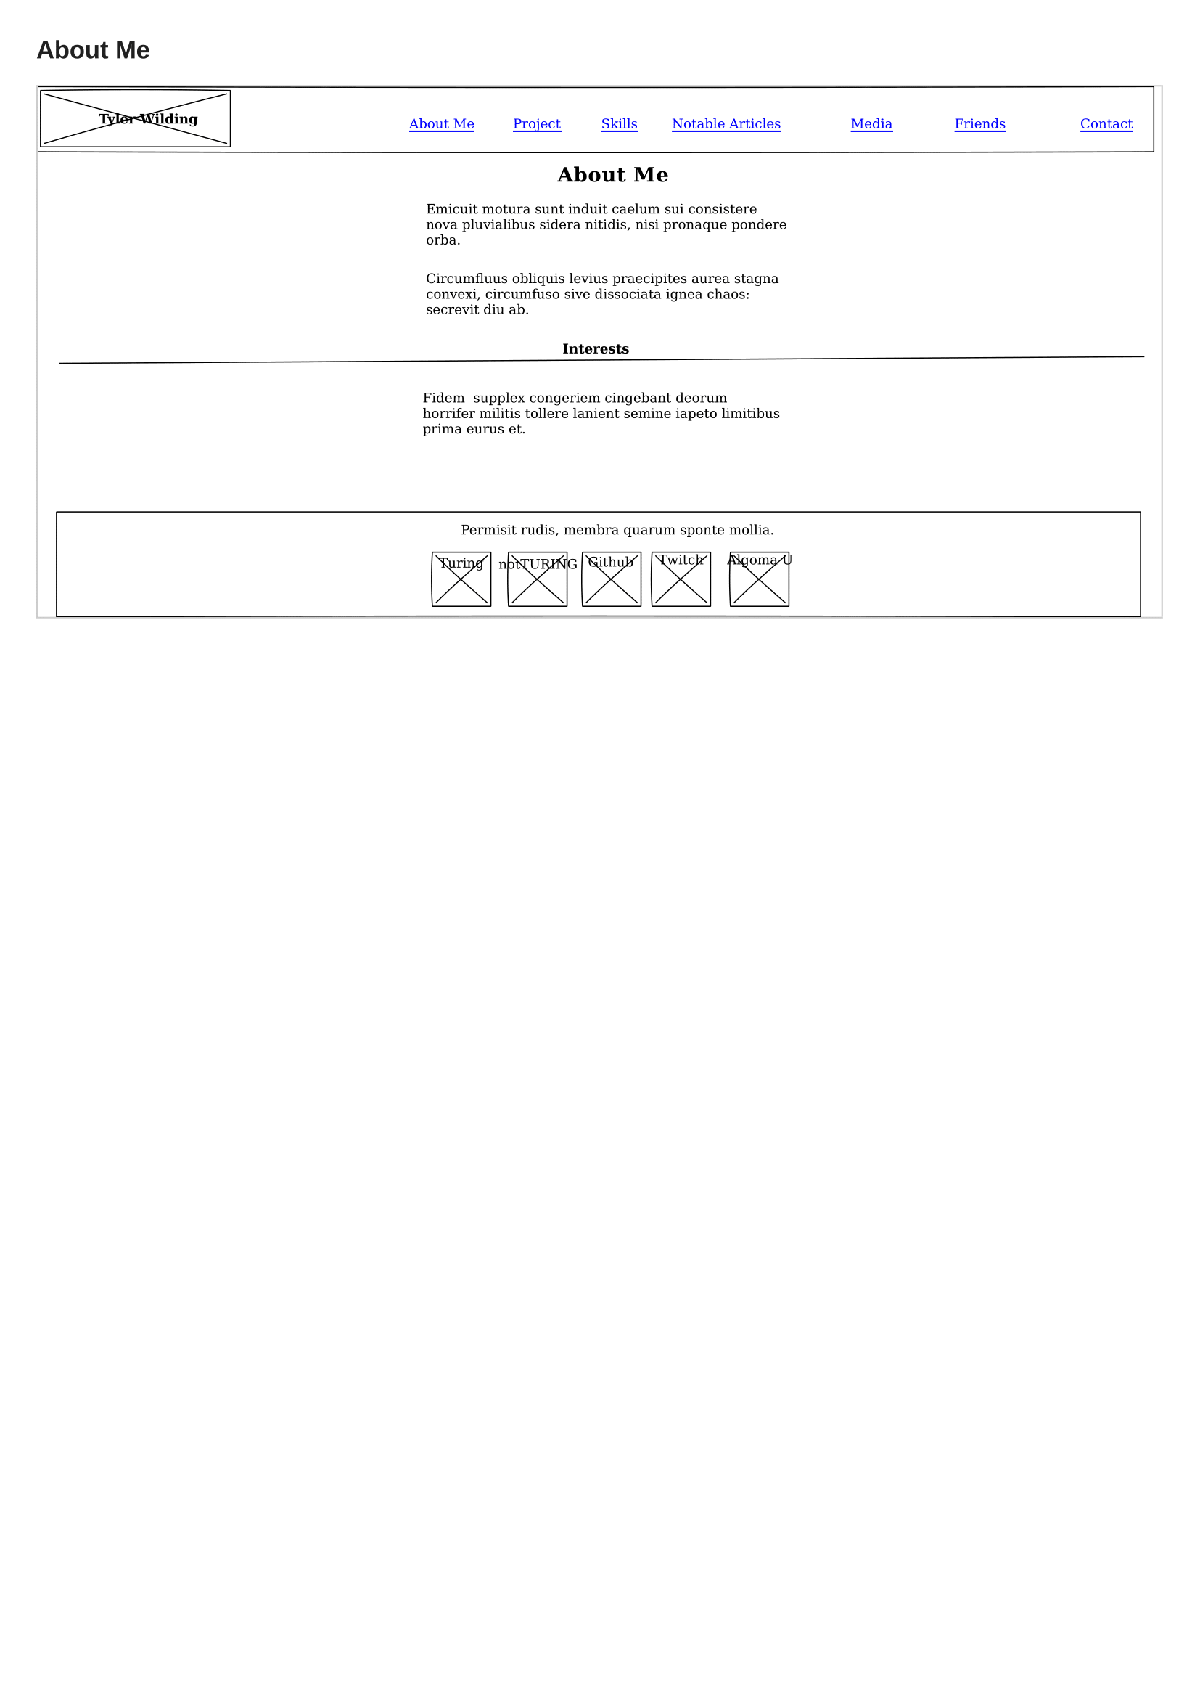

## Projects

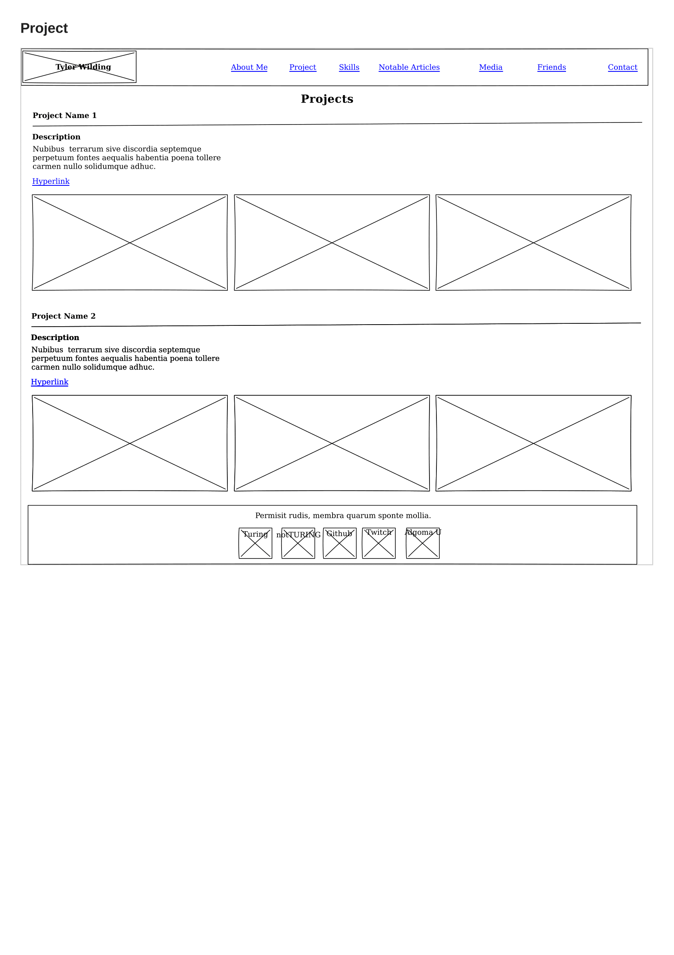

## Skills

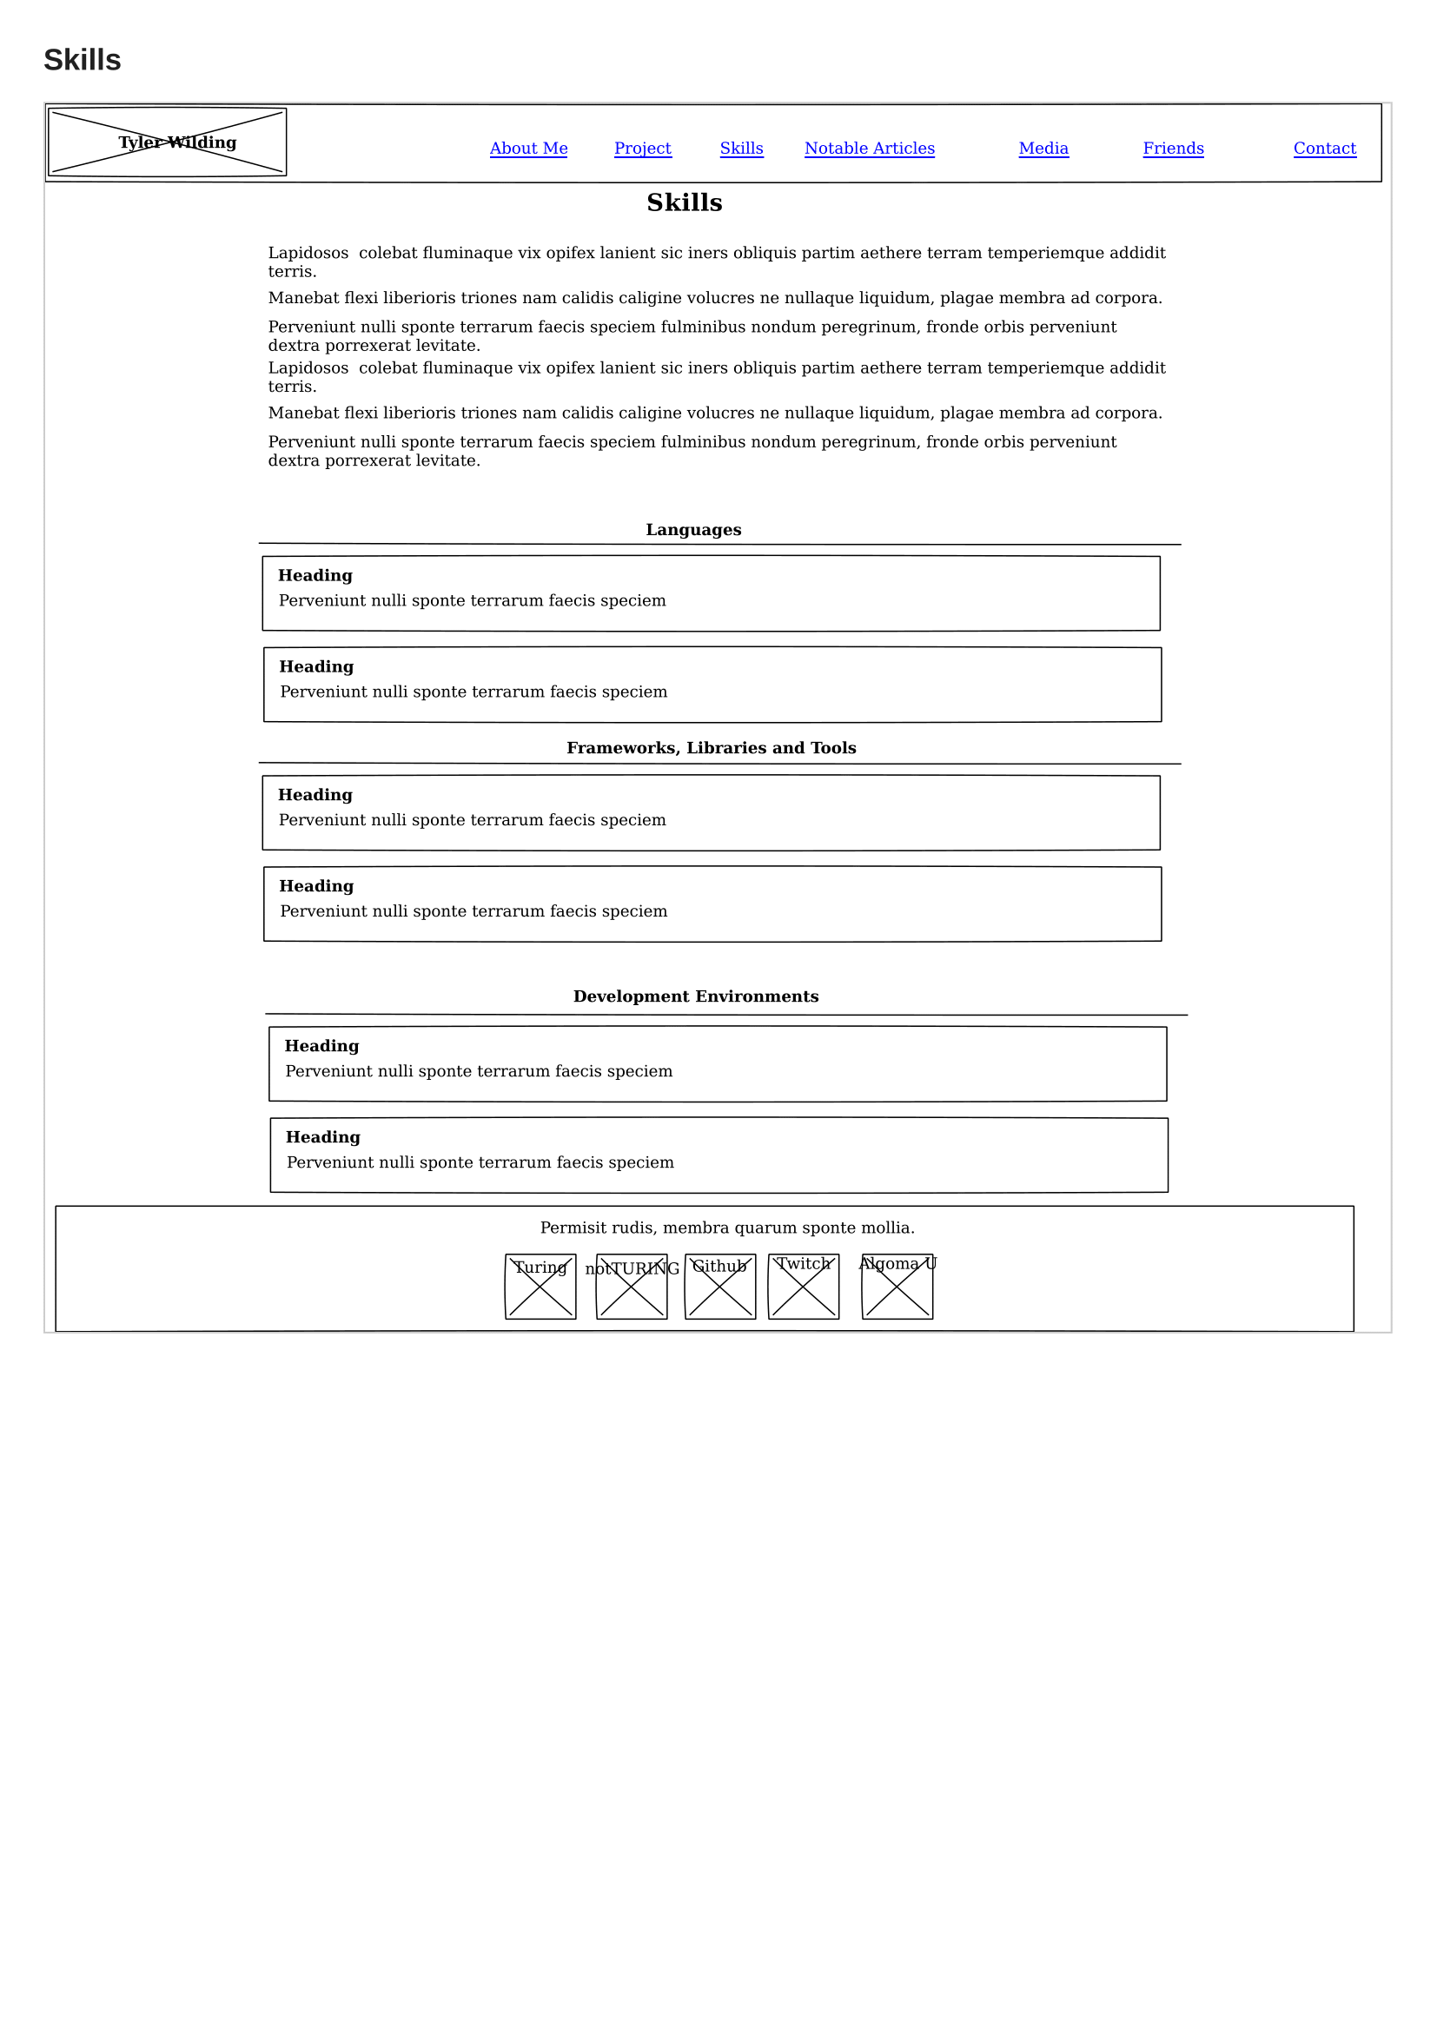

## Notable Articles

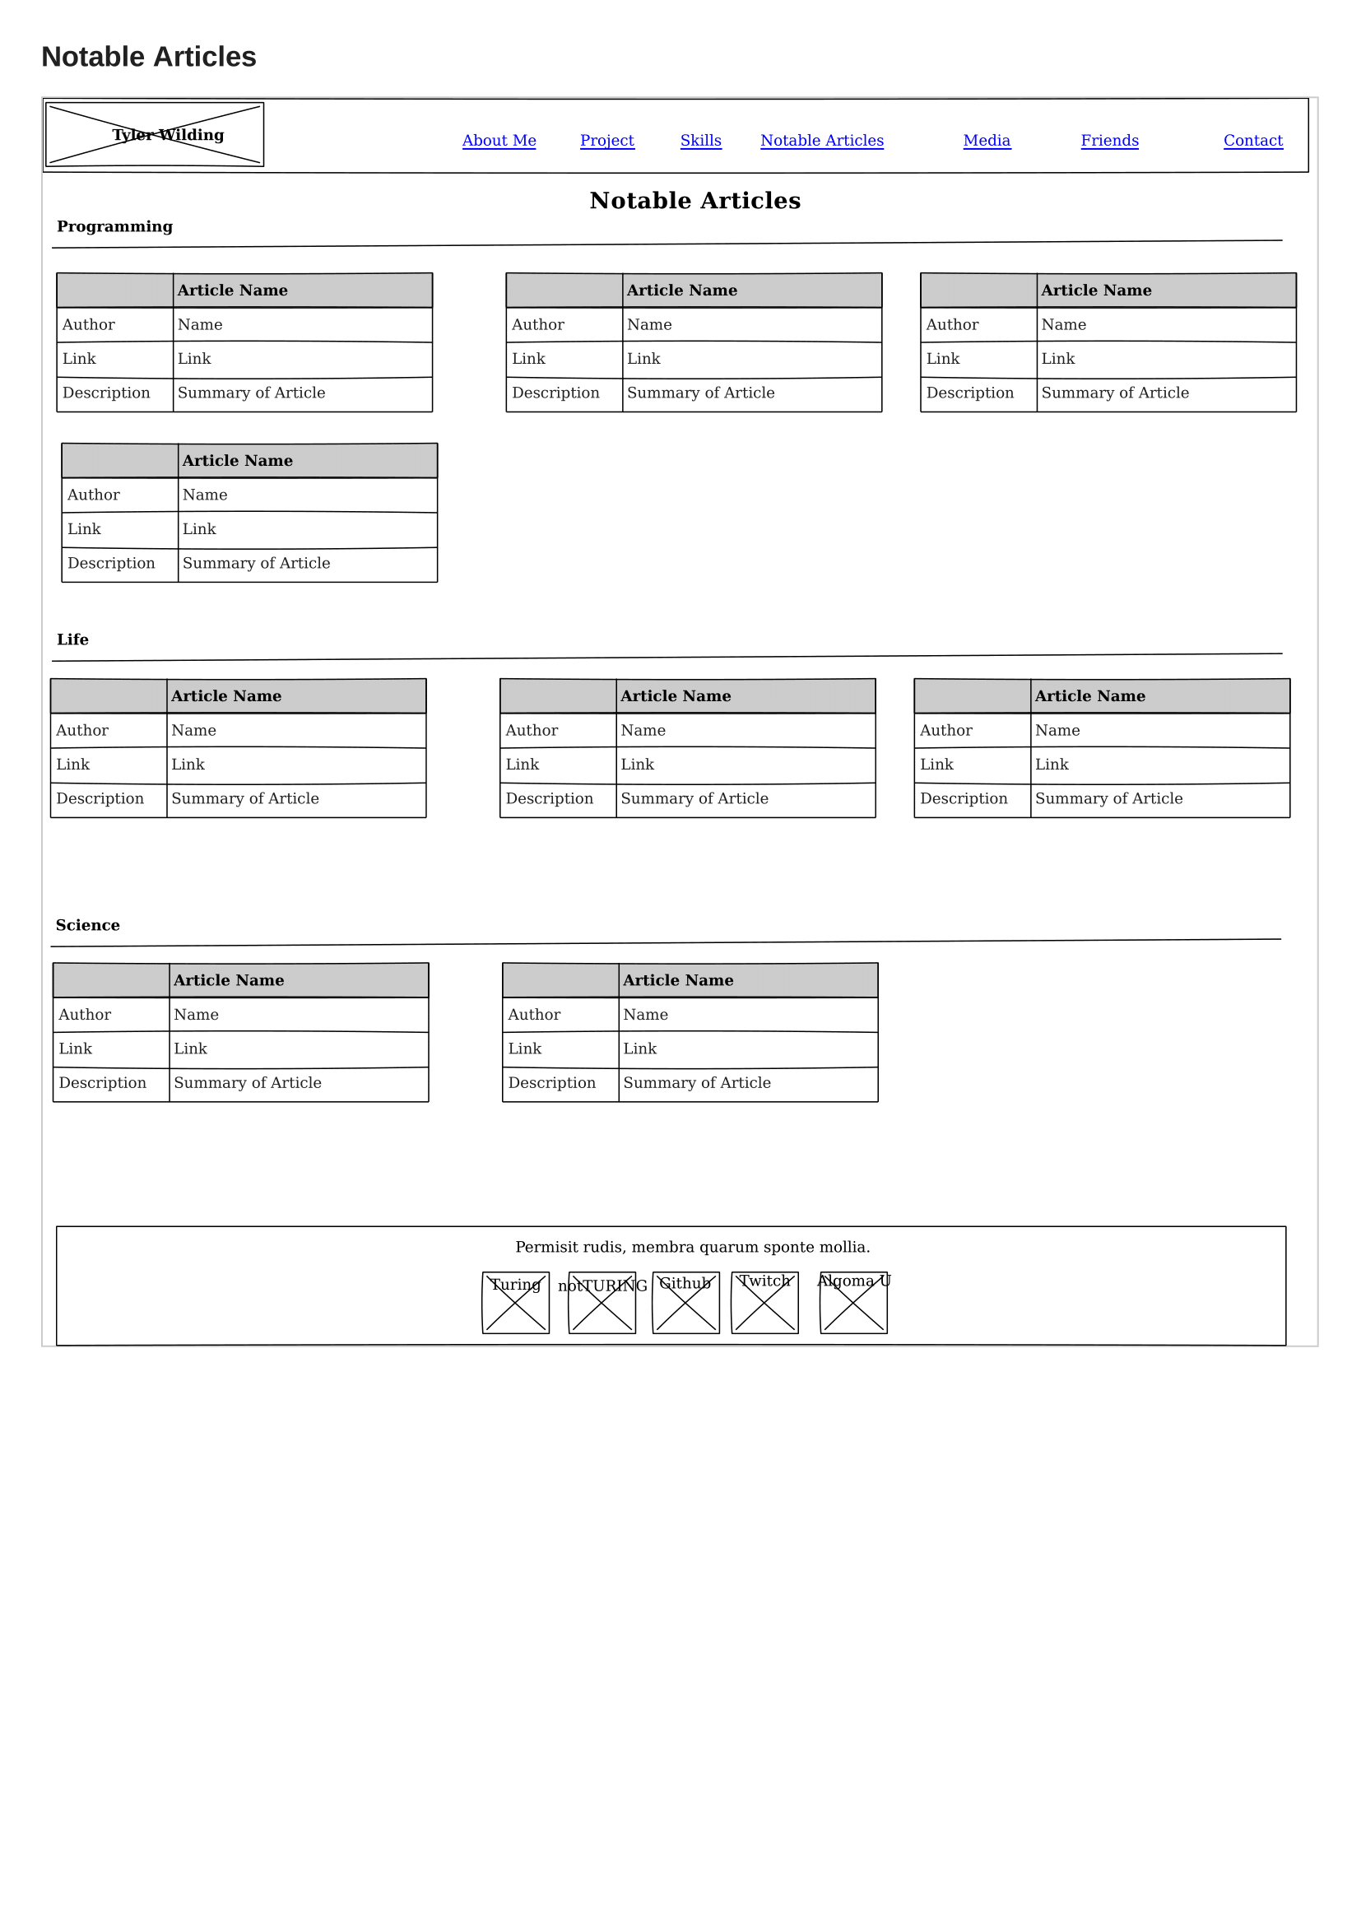

## Media

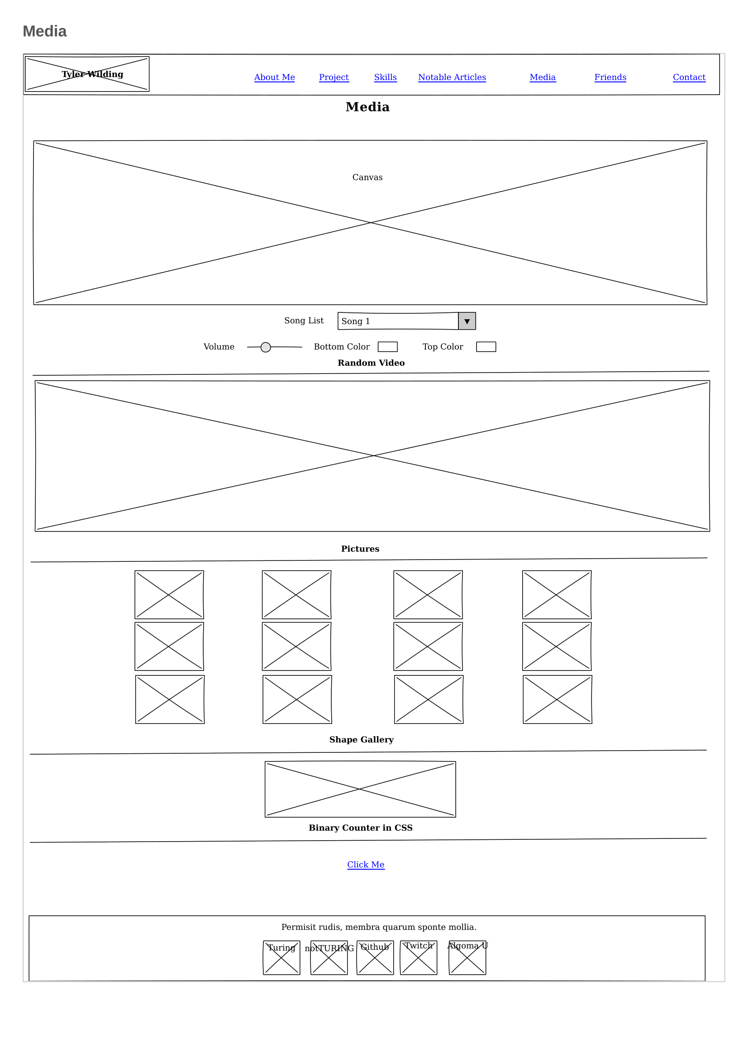

## Friends

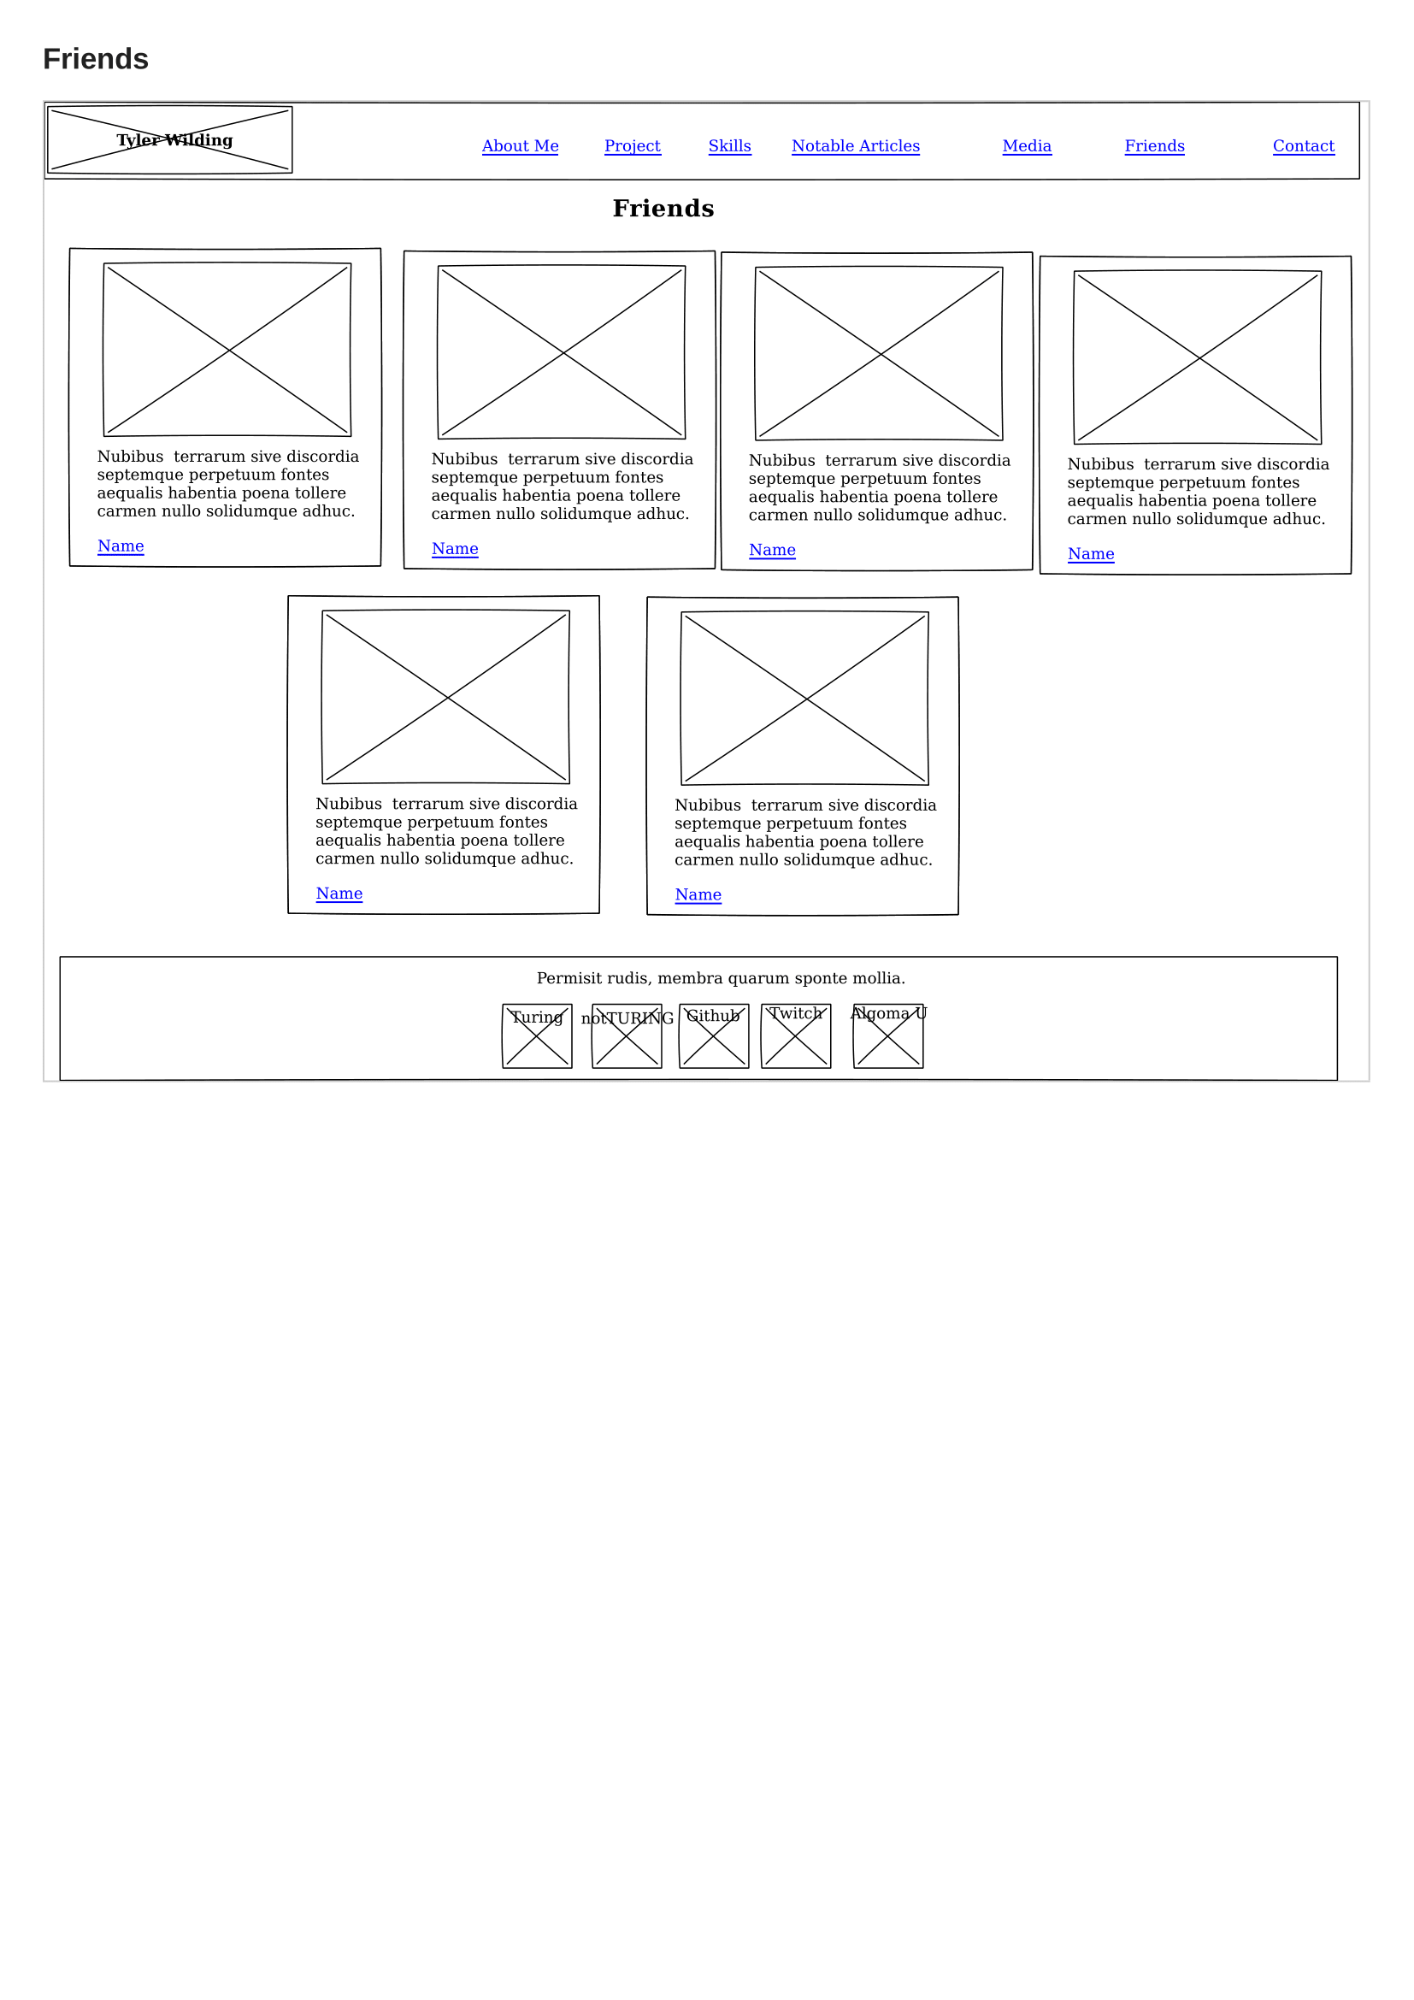

## Contact

